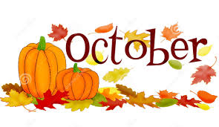
PS 177
Third Grade
Newsletter

Third Grade Newsletter

Reading Workshop
In Teacher’s College Reading, we are building a reading life. Our children are learning to pick books that interest them and that are “just right” and retell the most important parts.
Our students are building their stamina and improving their comprehension by making predictions and reading for meaning.
We will be starting to work with mystery books. Students will become familiar with detective work and finding clues to help them understand the story.
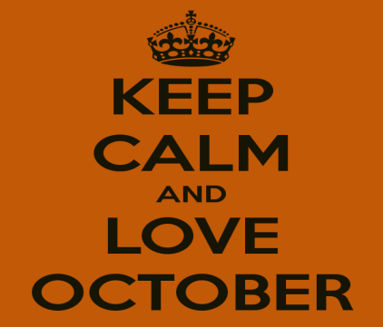

Social Studies
We are introducing World Geography and culture with a focus on map skills.

Science
This month’s focus is on tools that scientists use, inquiry skills and properties of matter.

Writing Workshop
We will be finishing up our unit on personal narratives with a published piece of a small moment. Then, we will move into our second unit, The Art of Information Writing.

Math Workshop
We will be finishing our work on addition and subtraction within 1,000. Review place value, rounding, and basic addition and subtraction facts. We will be moving into representing and interpreting data using graphs, tables, and charts. Please start reviewing multiplication.

Important Dates
October 2nd - Carnival
October 8th- No school Columbus Day
October 16th- PTA Meeting 3:30pm
October 31st – March of Dimes Walk

