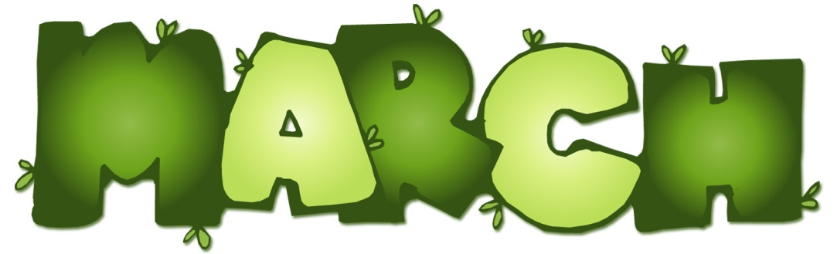

Third Grade Newsletter
PS 177
Third Grade
Newsletter

Reading Workshop
In Teacher’s College Reading, we will continue working on test sophistication. Students will practice close reading strategies as well as answering multiple choice questions. They will also code and roadmap stories.
Students are reading books on or above their individual levels. They will continue to log them. Please encourage them to read books at a higher level and to read out loud to someone at home. Please log on to MYON every night.

Social Studies
We will be learning about individual continents, countries within the continent and their traditions as well as continuing to work on map skills.

Science
3rd grade will continue their work and experiments with Mrs. Giardina

Writing Workshop
We will continue ELA test prep, with a focus on short and extended responses.

Math Workshop
We will prepare for the State math test. We will touch on all topics that may be included on the exam. New topics may include perimeter, area, fractions, time, measurements, and geometry. In addition, we will continue our GoMath unit in fractions and comparing fractions.

Important Dates
March 14- ½ Day Parent/Teacher Conferences
March 26- 2:20pm Build a Pal
March 28- Last Day afterschool test prep

