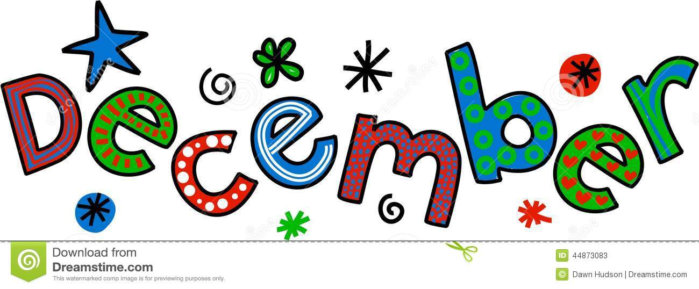
PS 177
Third Grade
Newsletter

Third Grade Newsletter

Reading Workshop
In Teacher’s College Reading, we will be working on nonfiction texts and using text features. Our children will be learning how to grasp the main idea, lifting the level of thinking in expository texts.
We will continue to find the main idea with supporting details as well as synthesizing information from different texts.
Students are reading books on their individual levels. They will continue to log them. Please encourage them to read books at a higher level and to read out loud to someone at home.

Social Studies
We will be discussing different cultures from around the world and how cultures and traditions change over time and in different regions. We will also be touching on seasonal holidays.

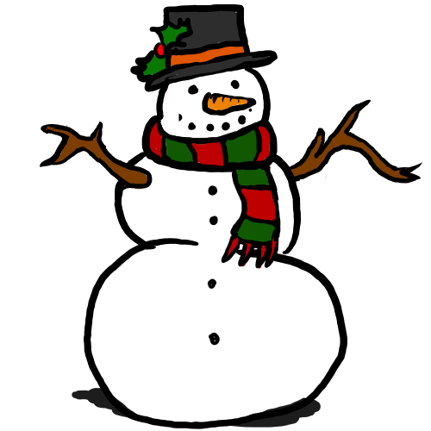
Science
We will be continuing our unit on energy with lab support from Mrs. Notter.

Writing Workshop
We are finishing our opinion pieces; then we will start our unit on nonfiction informational writing unit. This unit includes organizing our work into categories, using headings and subheadings and other text features.

Math Workshop
We will continue to be working on multiplication. It is imperative that your child memorizes the multiplication facts. They should already be reviewing skip counting (patterns) ex: 2, 4, 6, 8…

Important Dates
December 12-14, 17-18- Holiday sale
December 18- Winter Day Concert
December 19- Winter Evening Concert
December 21- Pajama Day
December 24-January 1 –Winter Break

